# [***Law & Order: SVU Ups Demore Barnes to Series Regular for Season 22***](https://tvline.com/2020/10/06/law-order-svu-demore-barnes-series-regular-christian-garland/)

By [Dave Nemetz](https://tvline.com/author/dave-nemetz/) / October 6 2020, 3:54 PM PDT

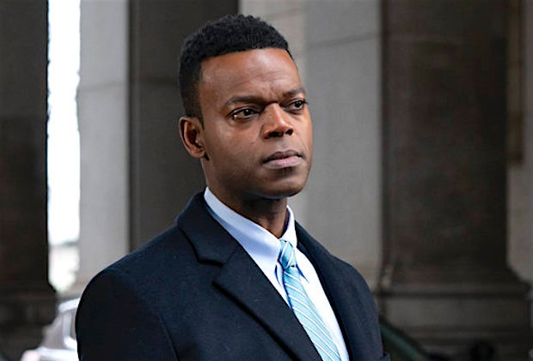Courtesy of NBC

There’s been a promotion at the [*Law & Order: SVU*](https://tvline.com/tag/law-and-order-svu/) station house: Demore Barnes, who plays deputy chief Christian Garland on the NBC procedural, will be a series regular when *SVU* returns for Season 22, our sister site [Deadline](https://deadline.com/2020/10/law-order-svu-demore-barnes-promoted-series-regular-season-22-nbc-drama-deputy-chief-christian-garland-1234592466/) reports.

Barnes joined the *SVU* cast last season as Garland, appearing in a total of six episodes. Debuting in Season 21’s third episode, Garland went undercover to track down a serial rapist targeting gay men and later had his faith tested when his pastor was arrested for statutory rape and embezzlement.

[**TV's Big Cast Changes (2020-2021)**](https://tvline.com/gallery/tv-cast-changes-spoilers-2020-2021-season/?ref=https://tvline.com/2020/10/06/law-order-svu-demore-barnes-series-regular-christian-garland/)

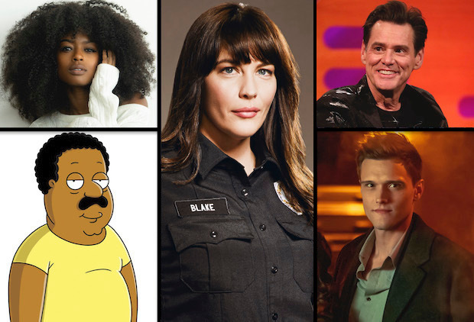

[**Launch Gallery**](https://tvline.com/gallery/tv-cast-changes-spoilers-2020-2021-season/?ref=https://tvline.com/2020/10/06/law-order-svu-demore-barnes-series-regular-christian-garland/)

*SVU* resumed filming Season 22 last month in New York City, after the global coronavirus pandemic brought virtually all TV production to a halt. (NBC renewed the long-running drama for [three additional seasons](https://tvline.com/2020/02/27/law-and-order-svu-renewed-season-22-nbc/) back in February.) The new season premieres Thursday, Nov. 12 at 9/8c on NBC; last season’s finale cliffhanger, with Ian McShane’s media mogul Sir Toby facing rape charges, [won’t be addressed](https://tvline.com/2020/09/01/svu-ep-season-22-premiere-sir-toby-trial-warren-leight/) in the premiere, but fans can expect to see Christopher Meloni [back as Elliot Stabler](https://tvline.com/2020/05/01/law-and-order-svu-stabler-season-22-premiere-christopher-meloni/) before he launches his own spinoff, *Law & Order: Organized Crime*, slated for midseason.

Barnes also plays Mr. Ibis on the Starz series *American Gods*, which is (still) set to return for a third season. His other TV credits include *The Flash*, *Hannibal*, *12 Monkeys* and *Titans*.